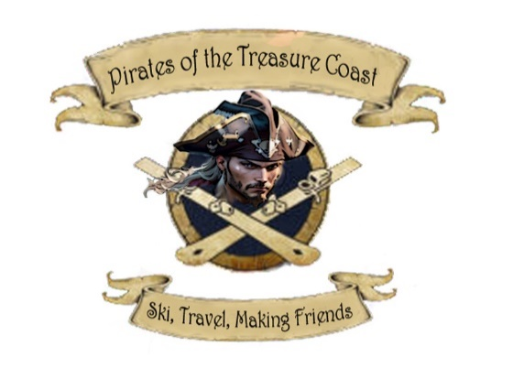
Pirates of the Treasure Coast Ski and Travel
C/O Capt. Lars (Larry Grayhills)
10376 SW Stones Throw Terrace
Palm City, FL 34990
TCPiratesSki@gmail.com
561-358-0730
TCPiratesSki.com

2025-2026 MEMBERSHIP APPLICATION

______New _____Renewal ______Single Bloke ______ Single Wench______ Family of Pirates______

Last Name:________________________ First Name:_______________________
Address: ___________________________________________________________
City: ___________________________ State: _________________ Zip: _______
Mobile Phone:__________________________ Sex: M____ F____ Not Sure ____ DOB:__________
Occupation:____________________ Email:_____________________________________________
Add a Club T Shirt ($20) Size______________
Spouse
Last Name:________________________ First Name:_______________________
Address: ___________________________________________________________
City: ___________________________ State: _________________ Zip: _______
Mobile Phone:_____________ Sex: M____ F____ Not Sure ____ DOB:__________
Occupation:____________________Email:______________________________________________
Add a Club T Shirt ($20) Size______________
Children (under the age of 21) List on reverse side with DOB

By signing below, I/we acknowledge that I/we have read, understand and consent to the following release:
Name(s):______________________________hereby apply for membership in the Pirates of the Treasure Coast Ski and Travel, Inc. for the June 1, 2025 to May 31, 2026 year. This CLUB is a non-profit organization created to promote group skiing, social and sports activities. I/We understand that the CLUB sponsored trips, programs and events often involve strenuous physical activity or involve risks inherent to group social and community functions. It is my/our responsibility to determine whether I/we should or should not participate in any activity. I/We recognize that I/we participate at my/our sole discretion and at my/our own risk. I/We specifically agree to assume all risk, responsibility and liability for any and all loss, injury and/or damage suffered by me/us, and/or my/our family while participating in any trip, party, social function, or other activity promoted or sponsored by this CLUB, including, without limitations, injuries, damage, and/or loss of property, caused by the negligence or failure to act of the Officers, Directors, Agents, and/or Representatives of this CLUB.

MEMBER’S SIGNATURE: ______________________________________________DATE:___________

Significant Other’s SIGNATURE:_________________________________________DATE:___________

SEND THIS FORM AND $35 (Individual) or $65 (Family) plus $20 for optional club t shirt/s to the Address Above

